Option Chain UI



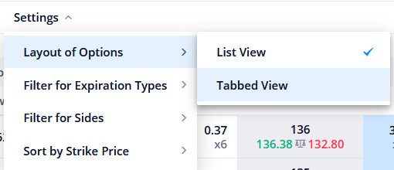

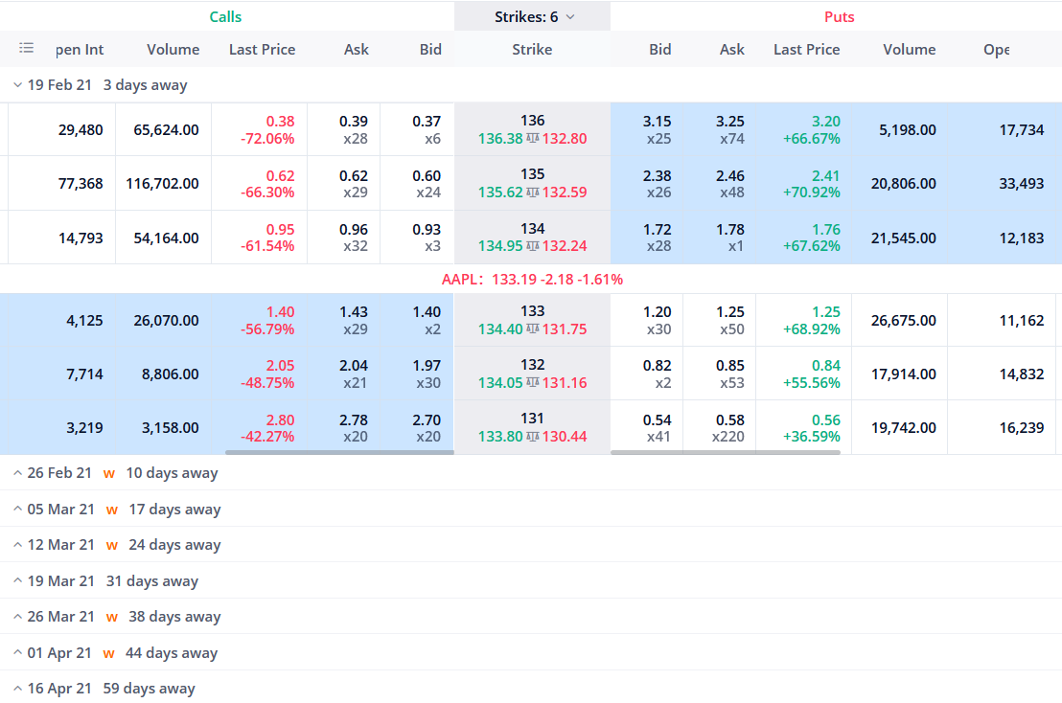

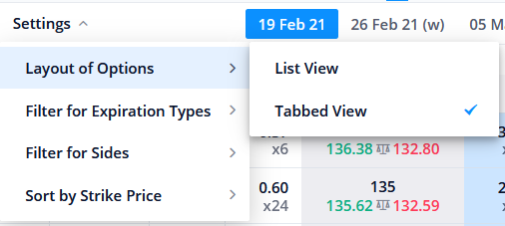

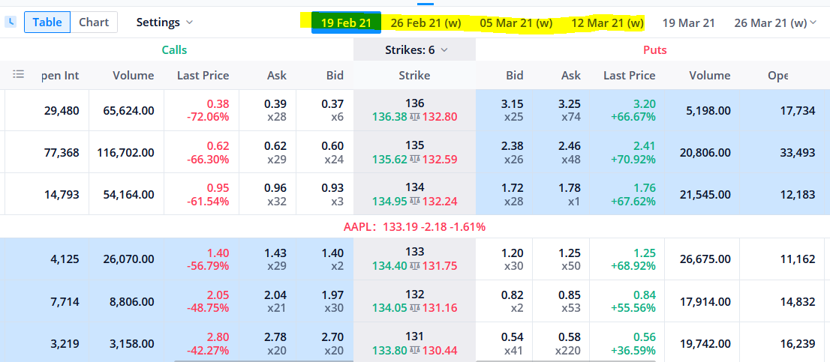

The color and table UI, make it look like this

Columns in Table



Column selection UI

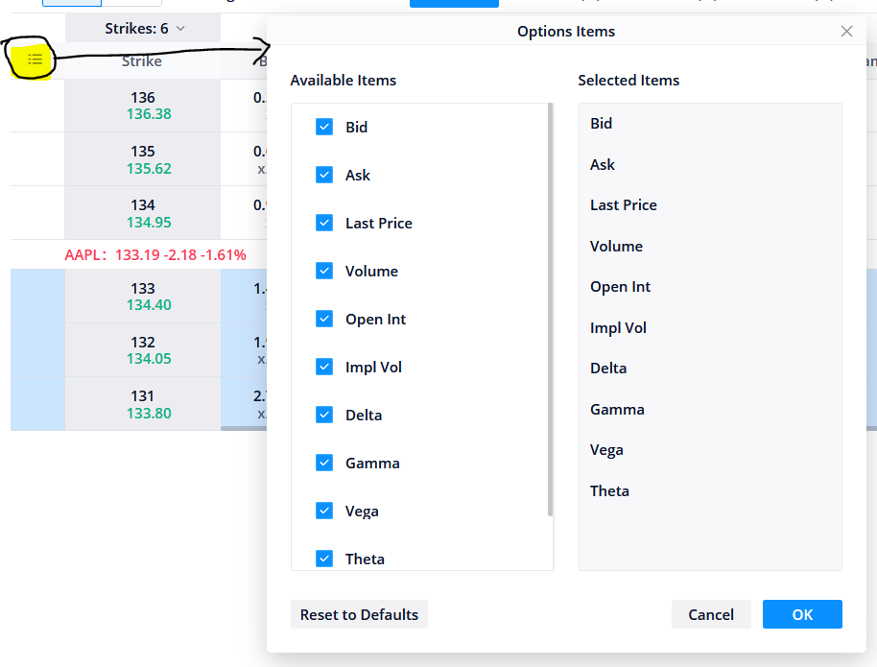

See the working on this UI at <https://app.webull.com/stocks>

Username – [gsakthidoss96@gmail.com](mailto:gsakthidoss96@gmail.com)

Pwd – Stupid@123

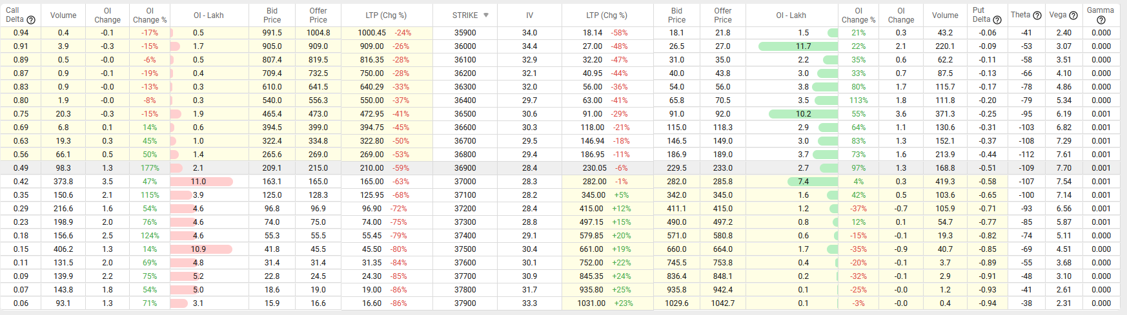

See the above UI at <https://web.sensibull.com/option-chain?expiry=2021-02-18&tradingsymbol=BANKNIFTY>

Option chain – how to get data.

Symbol – BANKNIFTY

Expiry – 25-Feb-2021

How to get data from Blaze API for entire option chain

You need to get for each symbol in each expiry

Which expiry to display – current week – next week. Current month, next month, far month.

Symbol (Unique Name)– (entire NSEFO – Instrument type = 1)

Expiry –

current week (25-Feb-2021)

next week. (4-Mar-2021)

Current month (25-Feb-2021)

next month (25-Mar-2021)

far month (29-Apr-2021)

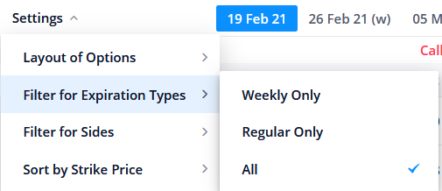

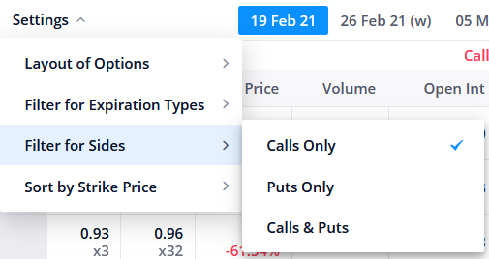

**Option Chain Chart Format**



Call LTP/Volume/OI/IV – **Chart1**, Put LTP/Volume/OI/IV – **Chart 2**, Straddle (Combine Call LTP + Put LTP) – **Chart 3**



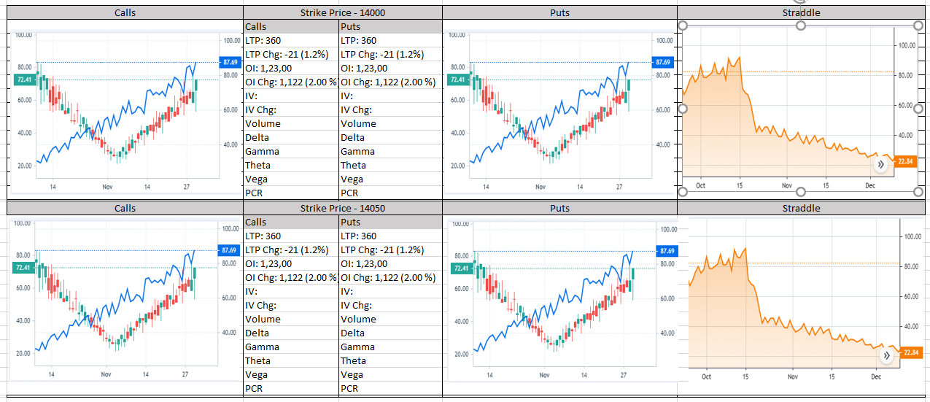

API that we will be using

1. Search API - http://144.126.252.175/v1/search?name=ian
   1. BANKNIFTY
2. Using BANKNIFTY,
   1. use the Instrument API - http://144.126.252.175/v1/instruments?name=BANKNIFTY&exchange=nse
      1. Get Spot Token
   2. Use the option chain API - http://144.126.252.175/v1/get_option_chain_instruments?name=BANKNIFTY&expiry=2021-06-24,2021-07-29
      1. Get Option Chain symbol Tokens
      2. Get Current Expiry Futures Token
   3. Use Get expiry API to get all the expiries for this instrument
      1. http://144.126.252.175/v1/get_option_expiry?name=BANKNIFTY
3. Using the Tokens, you will use Ticker API to subscribe to Real time data

http://144.126.252.175/v1/ticks?tokens=738561

Trading Section UI will be updated soon.